Lab 11

Single Cycle MIPS Datapath

(R-type and Load/Store)

* Pre-Lab

The code that should be in the instruction memory was given in the last lab which is as follows.

|  |  |  |
| --- | --- | --- |
| Address in memory | Instruction | Corresponding  Hexadecimal Code |
| 0 | add $9, $12, $13 | 018d4820 |
| 1 | add $10, $14, $15 | 01cf5020 |
| 3 | sub $8, $10, $9 | 1494022 |

Table 11.1

* In-Lab

1. Today’s Task

In this lab you will create a module **getoperand** enclosed by green box in Figure 11.2, and then connect it to **getinstruction**. It reads operands specified in the instruction from register file. Register File contains all registers ($t, $s, $a, $v; total 32) of mips processors. These register contain operands. The output of the register file will be connected to ALU, which will perform the required task on operands.

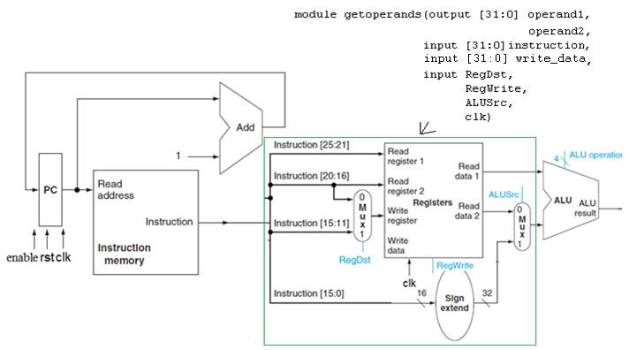

Figure 11.2

|  |  |  |  |
| --- | --- | --- | --- |
| Program Counter | Data Read from Instruction Memory | | Output of Complete Block  **‘Read data 1’** & **‘Read data 2’** |
| Actual Instruction | Data Read |
| 0 | add $9, $12, $13 | 018d4820 | Value of $12 and $13 |
| 1 | add $10, $14, $15 | 01cf5020 | Value of $14 and $15 |
| 2 | sub $8, $10, $9 | 1494022 | Value of $10 and $9 |

Table 11.2

* Post-Lab

Write module getoperands and combine it with module getinstruction (of Lab9). Test the combined

**Submission details**

* **Your lab report, a .doc file, should contain properly commented Post-Lab task code, with Screenshots(of print preview) of Schematic and waveforms, and Critical Analysis.**
* **The report must have a title page in the pescribed format.**
* **Name the .doc file RegNo.docx; eg SP14-BCE-99.docx**
* **Sumbit on portal.**